GW Power-Safe Ltd Carbon Reduction Plan

Publication Date
The date of publication is 30th June 2024.

Commitment to achieving Net Zero

GW Power-Safe Ltd is committed to achieving Net Zero emissions by 2030.

Baseline Emissions Footprint
Baseline emissions are a record of the greenhouse gases that have been produced in the past and were produced prior to the introduction of any strategies to reduce emissions. Baseline emissions are the reference point against which emissions reduction can be measured.

Baseline Year: July 2021-June 2022
Additional Details relating to the Baseline Emissions calculations.
Half hourly meter which is read every month for electrical consumption in addition we have solar PV generation which is monitored weekly to ensure our carbon values are accurate.
Baseline year emissions: July 2021-June 2022
EMISSIONS | TOTAL (tCO₂e)
Scope 1 | 58.6
Scope 2 | 3.4
Scope 3 | 2.4 (employee commuting)
Scope 3 | 0.6 (waste)
Scope 3 | 6.2 (business Travel)
Scope 3 | 0.0 (Upstream Distribution) These are currently not measured. We are actively liaising with our supply chain and manufacturers. This data is anticipated to be completed sometime in 2024.
Scope 3 | 0.0 (Downstream Distribution) These are currently not measured. We are actively liaising with our supply chain and manufacturers. This data is anticipated to be completed sometime in 2024.
Total Emissions | 71.2

Current Emissions Reporting

Current Report Year: July 2023 – June 2024
Additional Details relating to the Current Reporting Emissions calculations.
Half hourly meter which is read every month for electrical consumption in addition we have solar PV generation which is monitored weekly to ensure our carbon values are accurate.
Current year emissions: July 2023 – June 2024
EMISSIONS | TOTAL (tCO₂e)
Scope 1 | 57.8
Scope 2 | 3..18
Scope 3 | 2.6 (employee commuting)
Scope 3 | 0.6 (waste)
Scope 3 | 5.8 (business Travel)
Scope 3 | 0.0 (Upstream Distribution) These are currently not measured. We are actively liaising with our supply chain and manufacturers. This data is anticipated to be completed sometime in 2024.
Scope 3 | 0.0 (Downstream Distribution) These are currently not measured. We are actively liaising with our supply chain and manufacturers. This data is anticipated to be completed sometime in 2024.
Total Emissions | 69.98

Target Emissions Reporting
Target Year: 2030
EMISSIONS | TOTAL (tCO₂e)
Scope 1 | 30
Scope 2 | 0.2
Scope 3 | 1.0 tonnes (employee commuting)
Scope 3 | 0.4 (waste)
Scope 3 | 3.0 (business Travel)
Scope 3 | 0.0 (Upstream Distribution) These are currently not measured. We are actively liaising with our supply chain and manufacturers. This data is anticipated to be completed sometime in 2024.
Scope 3 | 0.0 (Downstream Distribution) These are currently not measured. We are actively liaising with our supply chain and manufacturers. This data is anticipated to be completed sometime in 2024.
Total Emissions | 0 tonnes in operation (energy) consumption.  34.6 in business operation (construction activity)

Emissions reduction targets
Our current electricity supply produces 977 kg CO₂, 63% will be supplied by solar, saving 618 kg CO₂ each year. 8,457 KWh will be exported, saving 1,796 kg CO₂ each year. TOTAL SAVINGS 2,414 kg CO₂ each year.

In order to continue our progress to achieving Net Zero, we have adopted the following carbon reduction targets.

We project that carbon emissions will decrease over the next five years to 34.6 tCO₂e by 2030. This is a reduction of 48.6%

Progress against these targets can be seen in the graph below:

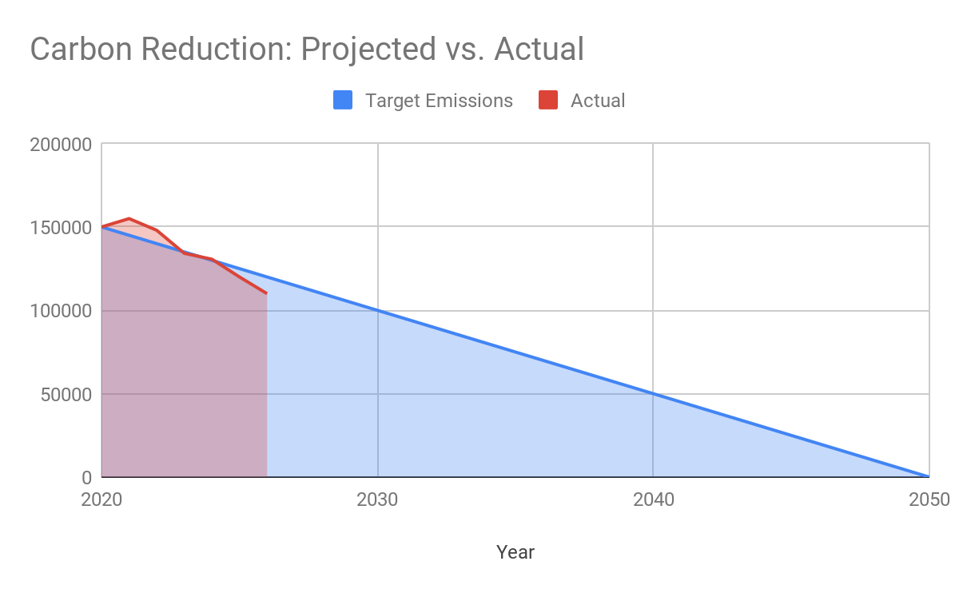

Carbon Reduction Projects

Completed Carbon Reduction Initiatives
The following environmental management measures and projects have been completed or implemented since the 2021/2022 baseline. The carbon emission reduction achieved by these schemes equate to 2,414 tCO2e, a 4.92%ge reduction against the 2021/2022 baseline and the measures will be in effect when performing the contract.
We have LED/PIR lighting controls in the offices, we are offsetting out fuel emissions by planting trees, we have added solar PV to our offices. We have put practices in place in the workplace to reduce waste.

In the future we hope to implement further measures such as:

We are looking into electrification of some of fleet vans in the future.

Declaration and Sign Off
This Carbon Reduction Plan has been completed in accordance with PPN 06/21 and associated guidance and reporting standard for Carbon Reduction Plans.
Emissions have been reported and recorded in accordance with the published reporting standard for Carbon Reduction Plans and the GHG Reporting Protocol corporate standard and uses the appropriate Government emission conversion factors for greenhouse gas company reporting.
Scope 1 and Scope 2 emissions have been reported in accordance with SECR requirements, and the required subset of Scope 3 emissions have been reported in accordance with the published reporting standard for Carbon Reduction Plans and the Corporate Value Chain (Scope 3) Standard.
This Carbon Reduction Plan has been reviewed and signed off by the board of directors (or equivalent management body).

Signed on behalf of the Supplier:
……Daniel Haley………(Managing Director)………………….
Date: 30th June 2024………….………………………………………

